Challenge 3: The 28 Day Challenge

As you have been learning, humans are great at asking questions, making connections, and trying new things. But we are also creatures of habit. Explore our remarkable abilities to change by trying something new or breaking a habit for at least 28 days. Get on task, break an addiction, eat healthy, start exercising, learn an instrument or a language ... whatever you think might make your life a little bit better – go for it!

Step 1. Get Motivated

At the most basic level, humans have evolved to seek pleasure and to avoid pain. In order to complete this 28 Day Challenge you need to convince yourself that it is worth it by maximizing the pleasure you will receive and the pain you will avoid by succeeding. Think deeply about the following and really trace out all of the rewards and consequences of your challenge.

The Pleasure I will Receive if I Succeed: The Pain I will Endure if I do not:
_______________________________ __________________________________
_______________________________ __________________________________
_______________________________ __________________________________
_______________________________ __________________________________
_______________________________ __________________________________

Add pleasure by having a friend join you. Add pain by creating harsh consequences and asking a friend to hold you to it.

2. Repair your Reward System and increase your will power.

In lesson 3 we learned that your motivation is controlled by the dopamine levels in your brain, which rise in anticipation of a reward. However, when we constantly try to elevate dopamine levels in artificial ways by indulging in supernormal stimuli (sweet & fatty foods, social media feeds, Netflix binges, high-speed porn, etc.) we become desensitized to dopamine. Our motivation declines and we lose willpower, further feeding the cycle of seeking supernormal stimuli. During these 28 Days, try to avoid supernormal stimuli and monitor your motivation and will power. You should see improvements.

Write down all of the supernormal stimuli that you need to block out over the next 28 Days.
__________________________________________________________________________________________________________________________________________________________________________

For a little extra motivation, write down all of the things that would be better in your life if you had more will power: _______________________________________________________________________________________________________________________________________________________________________________________________________________________________________________________________

3. Find the Time

Make a clear plan for success. You may need 30 minutes or an hour a day to complete this challenge. Put it on your calendar, scheduled right down to the minute. You may need to clear some time to do this, which will mean weighing your priorities and then committing to them. If the pleasure/pain ratios you determined in Step 1 are really worth it, it should be clear to you where you can make time in your schedule.

Write down your plan / schedule:
_______________________________________________________________________________________________________________________________________________________________________________________________________________________________________________________________

4. Break your Pattern. Change your Routine.

In lesson 3 we learned that humans have adapted to seek comfort, store fat, and feel stress. But we also developed the power and ability to reflect on our behavior and change it. But our brain does not have time to reason about all behaviors and so it codifies routinized behaviors into habits which often occur outside of our conscious reasoning, and are controlled by the same area of the brain that controls our instincts and impulses, so habits can feel like irresistible urges that are out of our control.
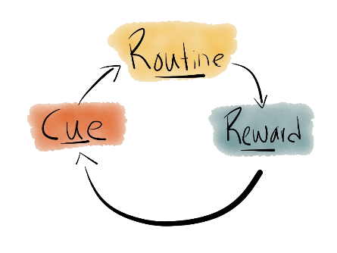
Here is a diagram of the “habit loop” introduced in Lesson 3. Note that the loop starts with a cue, which triggers the routine, which brings a reward that reinforces the cue.

We cannot change the cue. They come from the environment. But we can make a conscious effort to break the pattern by replacing the routine. The key is to make sure that the new routine brings with it a reward. Otherwise it will not reinforce the cue. Hopefully, after 28 days of consciously forcing yourself to change your routine, you will be well on your way to making it automatic.

Consider the habit you are trying to break, or any of the supernormal stimuli that you will be trying to avoid over the next 28 days.

What cues you to do this behavior? ______________________________________________

What do you think you really need at that moment when you start the routine? _____________________________________________________________________________

What is the routine? ____________________________________________________________

What rewards does it bring? ______________________________________________________

What new routine will you use to replace the old one? _________________________________

5. Change your Environment.

In Lesson 3 we also learned that our current environment bombards us with easy access to supernormal stimuli, comforts, and distractions specifically designed for our evolutionary triggers. To maximize your chance for success, you may need to change your environment. For example, if you want to exercise more by riding your bike rather than driving, park your bike behind your car and put your keys on a high shelf that requires a ladder (you can put the TV remote and any other distractions up there while you are there.) If your finger is on auto-pilot to launch a social media app on your phone, move a more productive app into that position (like a Kindle book-reading app).

What changes can you make to your environment to improve your chances of success? _______________________________________________________________________________________________________________________________________________________________________________________________________________________________________________________________

